**Week 5 Submission**

**Ameer Karas**

**44948956**

**Question 1**

1. 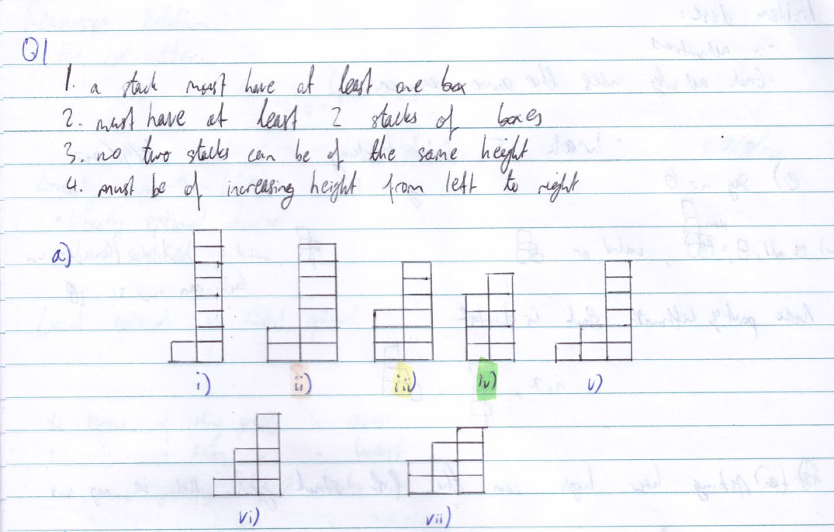
2. 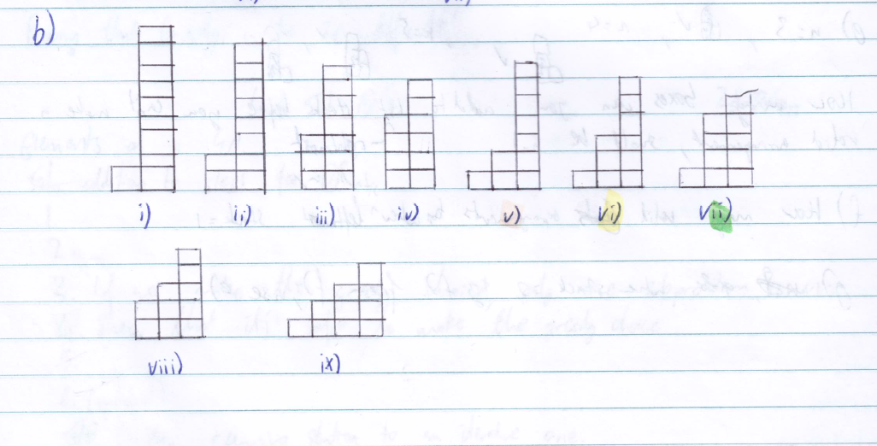
3. Of part (a), arrangements (ii), (iii) and (iv) are arrangements (v), (vi) and (vii) (respectively) of part (b), with an additional 3rd stack of one box. This does not hold for arrangement (i) of part (a), however, as adding an additional stack of one box would break rule 3 (no two stacks can be of the same height).
4. Suppose that for *n* boxes, you can create arrangements of *i* stacks. Then, for arrangements for *n* + 1 boxes, you can add another stack of one box to the arrangements of *n* (assuming the left-most stack has 2 or more boxes) to have *i* + 1 stacks.
5. My assumption for this question is that you’re asking: “can a valid arrangement be made if the leftmost stack has two boxes”. You are able to add to a stack of one box if, for the leftmost stack of *j* boxes, you have *j* + 1 boxes remaining to make a taller stack. For the following example:

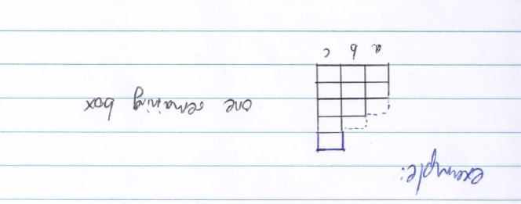

We can see that if placing the remaining box (shown in blue ink) on stack ‘a’ or stack ‘b’ compromises the rule set, we can always place the box on the right most stack.

1. Suppose *i* is the number of stacks in an arrangement. To extend the arrangement by one stack, there must be *i* + 1 boxes spare (spare from the boxes used to maintain rules 3 and 4) create an additional stack. This is because every stack must receive a box to go up in height to maintain rules 3 and 4, and the additional box (the ‘1’ from *i* + 1) is used for the new stack.
2. Where ‘k’ is the amount of boxes remaining to be stacked and ‘i’ is the amount of stacks.

